RESUME
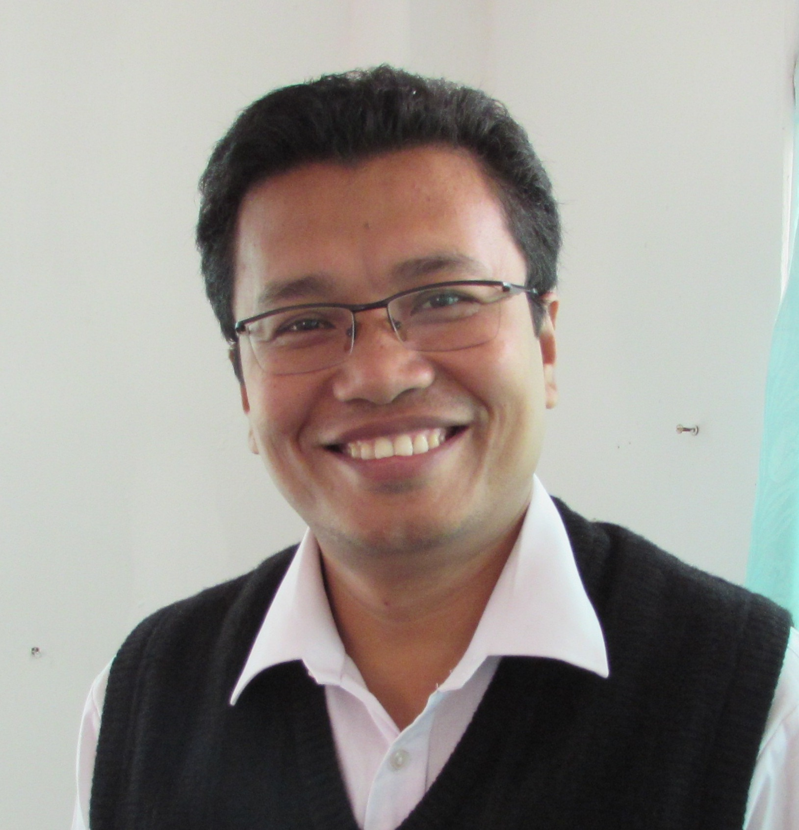

Name : BISWAJIT SINHA
Mobile : + 91 9612074123 / 9774474537
Email : sinhabiswajit@gmail.com

Nationality : INDIA
Date of Birth/Place : 15.01.1974 / Halahali, Dhalai, India
Marital Status : MARRIED
Language known : Manipuri, Bengali, English and Hindi

Education:
- Master of Arts (Education), Tripura University
- Bachelor of Education (B. Ed), Tripura University
- Bachelor of Commerce (B.Com), IGNOU, New Delhi
- Studied Computer Application and Office Management, NEDI, Panchgani

Work Information:
- Serving as a Principal of the Brilliant Stars School, Udaipur, Tripura
- Served as a Vice-Principal of the Brilliant Stars School, Udaipur, Tripura
- Coordinator, Service Learning Project, Brilliant Stars School, Udaipur, Tripura
- State Coordinator, Tripura Training Institute, Agartala, India
- Served as Secretary of the State Baha’i Council of Tripura, Honorary service
- Served as Treasurer of the State Baha’i Council of Tripura, Honorary service

Professional Development & Activity:
- Conducting professional workshop on Digital Citizenship for Brilliant Stars School Teachers, 2017

- Hosted 2 teachers for Global Classroom at Brilliant Stars School for a week., 2017. A program sponsored and hosted by US Dept. of State and IREX, Washington DC.

- Organized and hosted Capacity Building Program on Classroom Management and on Social Science in collaboration with Centre of Excellence, CBSE, Kolkata, 2017

- Conducting professional workshop on Learning for Brilliant Stars School Teachers, 2016

- Conducting professional workshop on Literature Circle for Brilliant Stars School Teachers, 2016

- Successful completion of full semester long program called International Leaders in Education Program (ILEP) at Arizona State University, Spring 2016 sponsored and organized by US Dept. of State and IREX. Washington DC, 2016

- Seminar on Institutional Capacity Building at Regional Level International Teaching Centre, Baha’i World Centre, Haifa, Israel., 2015

- Training on Growth and Fixed Mindset and Skill-based Lesson planning, By faculty members of the American Embassy School, New Delhi, 2015

- Presented Service-Learning Project to elementary school teachers at American Embassy School, New Delhi, 2015

- Interaction and observation of classrooms of American Embassy School and Gateway School of Mumbai, 2015

- Capacity Building and Knowledge Dissemination organized by Indian Council for Research on International Economic Relations (ICRIER),, New Delhi, 2014

- Training on Continuous Comprehensive Evaluation (CEE), organized by PC Training Institute an affiliated agency of the CBSE., 2014

- Training on differentiated instruction, multi-modal assessment, logical consequence, making learning visible by international educationists and trainers at Brilliant Stars School campus, Udaipur, Tripura, 2014

- Capacity Building and Knowledge Dissemination organized by Indian Council for Research on International Economic Relations (ICRIER), New Delhi, at Guwahati, 2014

- Hidden Gems Math Program, Witthayakhom School, Yasothan, Thailand, 2007

- National Youth Camp, National Spiritual Assembly of Thailand, Khao Yai National Park, Thailand

- Seminar on Junior Youth Spiritual Empowerment Program National Spiritual Assembly of India, New Delhi, 2005

Publication:
- Published a report on Nutrition a project conducted by Brilliant Stars School students as a part of Service Learning Project, 2014

- Jointly published a report on Garabage and Waste Management with Mr. Anuj Iyer, a year long project conducted for Brilliant Stars School students as a part of Service Learning Project, 2013

“Every child is potentially light of the world, as the same time its darkness” - Baha’i Writings

